Peter the Great St. Petersburg Polytechnic University

_______________________________________

[Institute of Computer Science and Technology](http://english.spbstu.ru/structure/institut_computernikh_nauk_i_tekhnologiy/)

Department of Computer Systems & Software Engineering

Lecture

*ModelSim GUI Essentials*

student:

Ivanov Il’ya

group: 3530901/70203

lecturer:

Antonov A.P.

Saint-Petersburg

2020

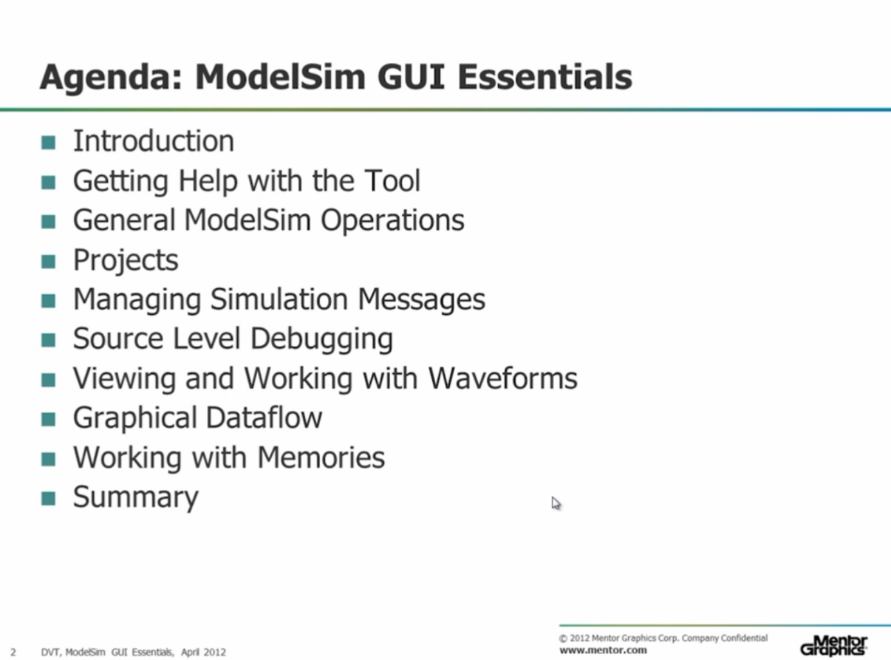

Work plan for this lecture.

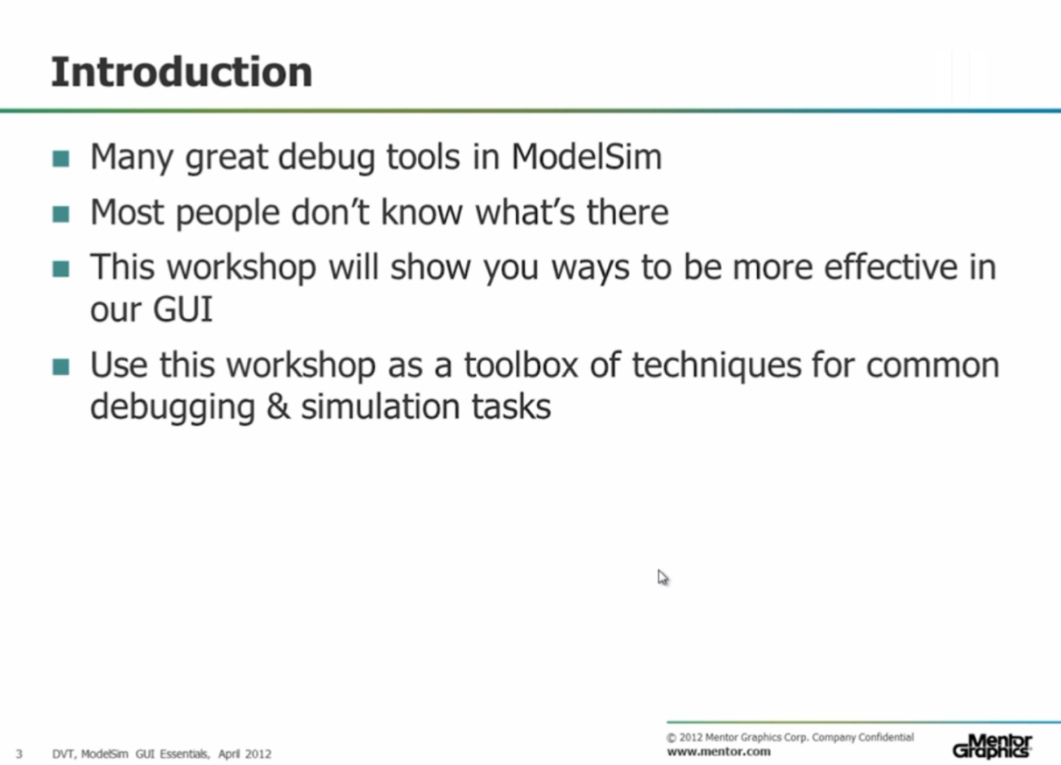

This lecture will show you many debug tools in ModelSim and you will become much more effective in using the ModelSim GUI.

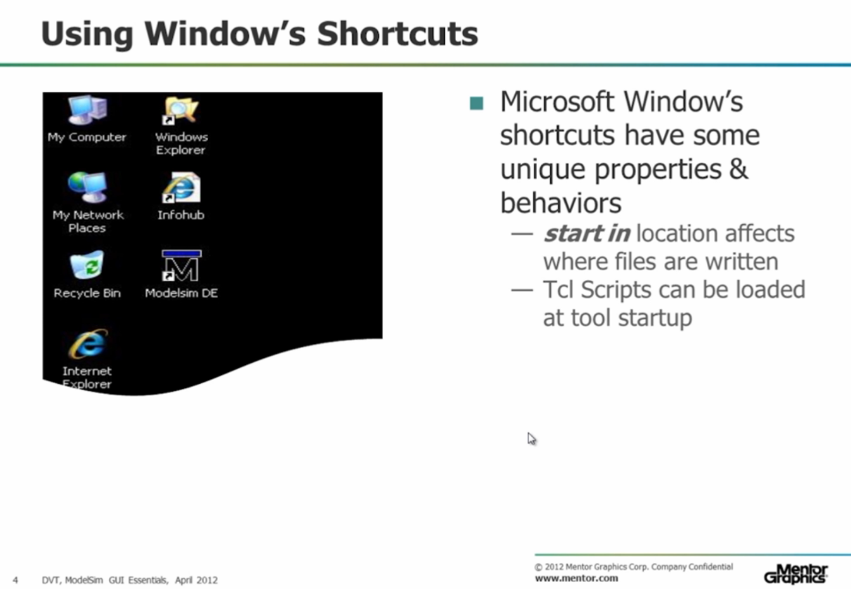

We can start ModelSim using Windows desktop shortcut. However, every time we launch a new project, we need to change directory to this project. To avoid this, we can go to shortcut properties (by right clicking on the shortcut and selecting “Properties”).

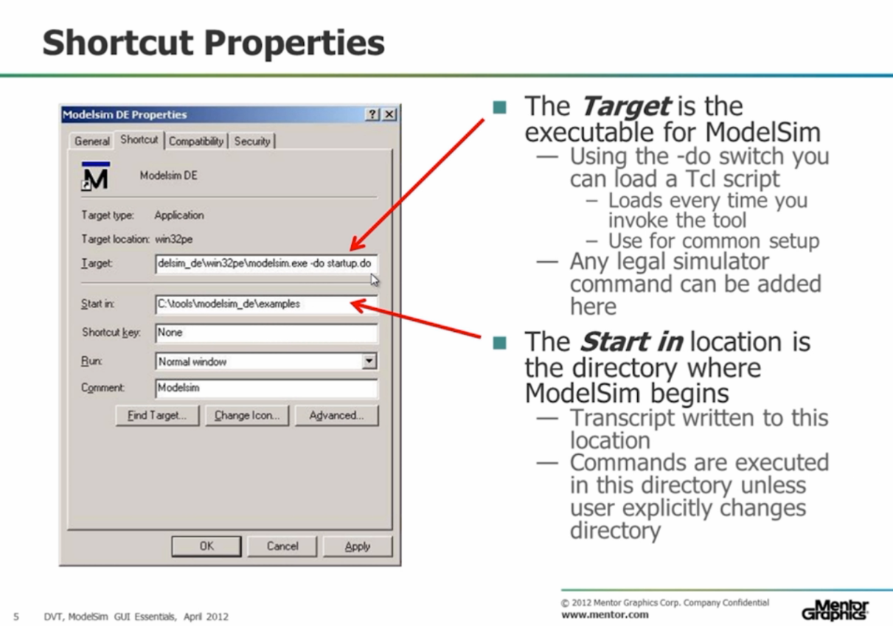

Now we can change the “Target” and “Start in” properties to avoid changing the directory when starting a project.

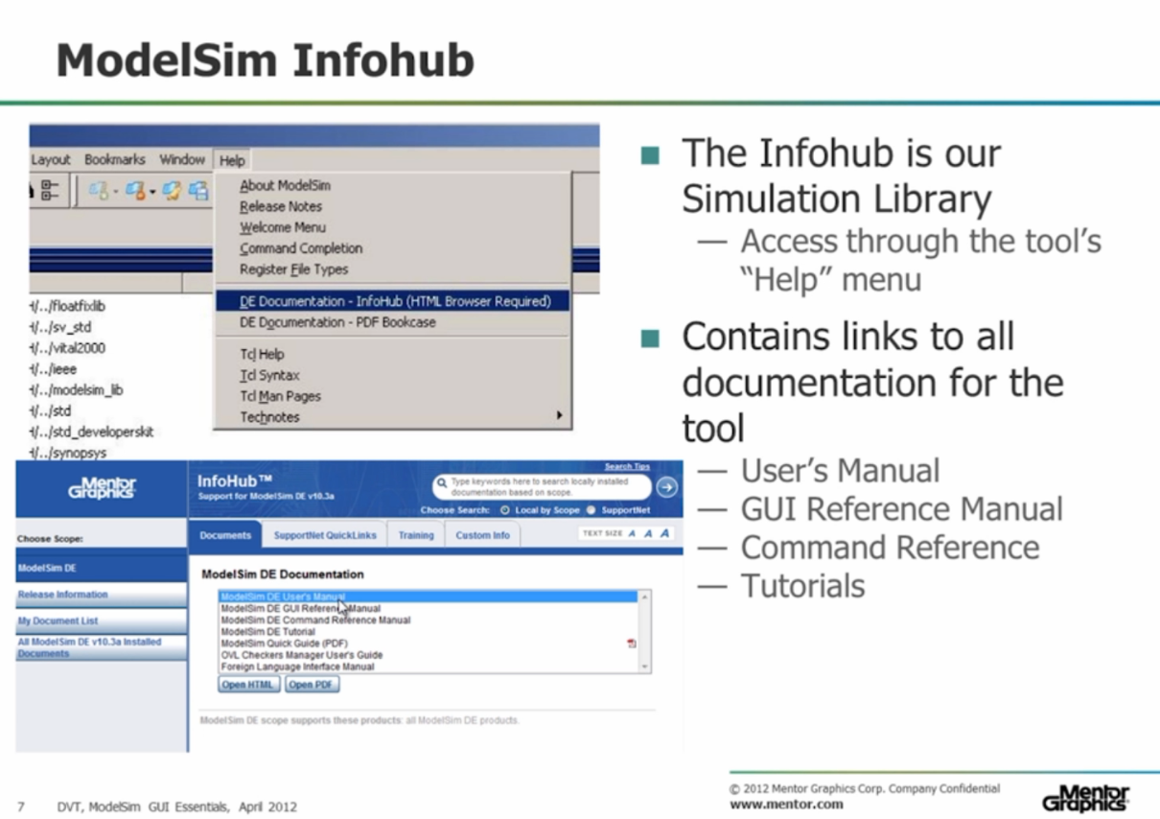

To get information about everything in ModelSim we can use “help” menu, where we can select PDF Bookcase (set of PDF manuals) or InfoHub.

In InfoHub we can search on topics, keywords, etc. In addition, InfoHub gives us access to various manuals.

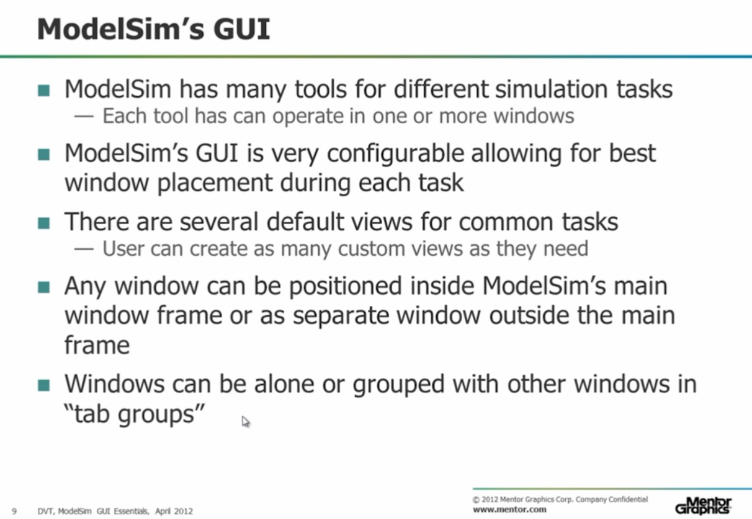

ModelSim GUI has many tools, the position of which on the screen is very well customizable.

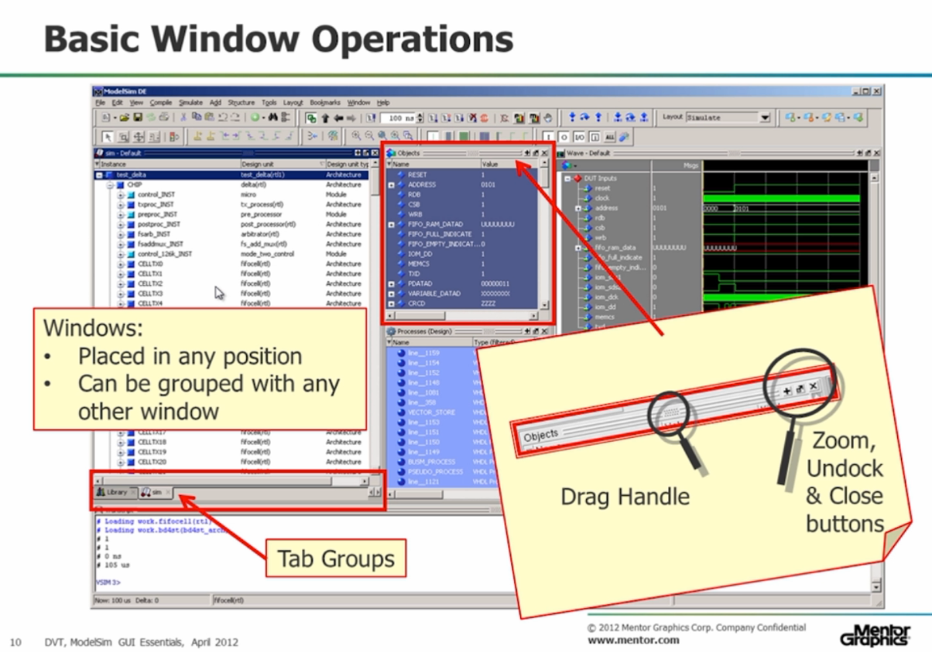

An example of the location of tools on the screen and the operations that we can perform with their windows.

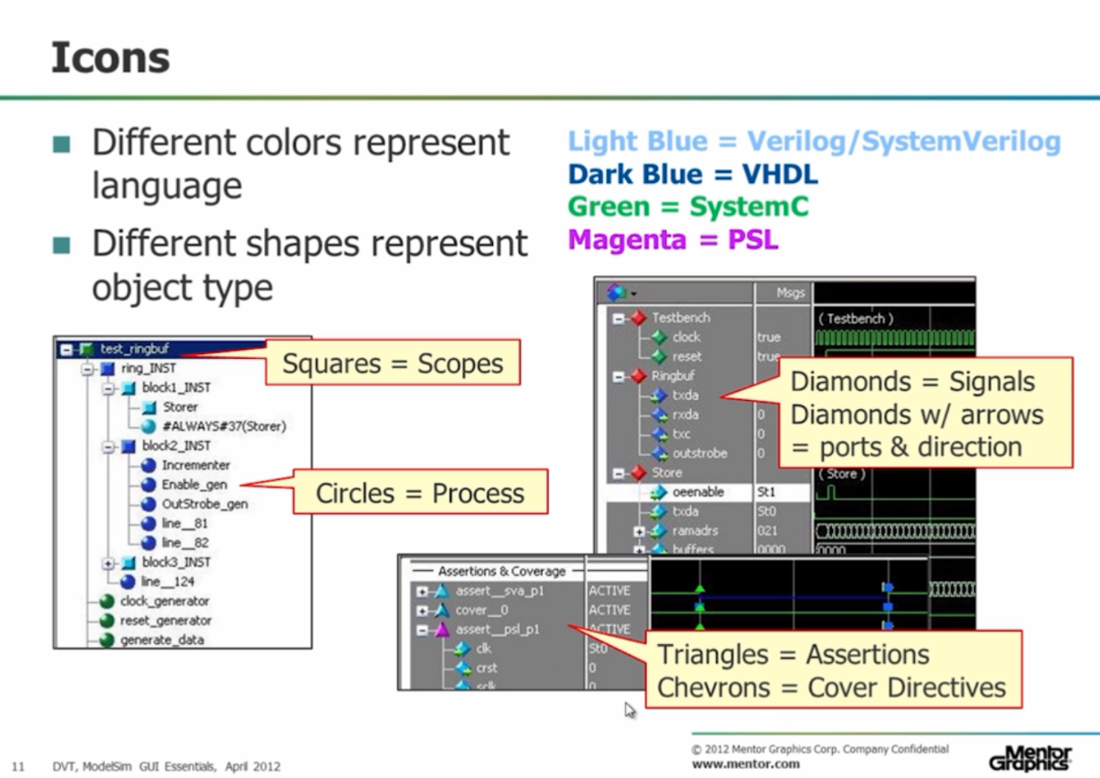

In ModelSim, we see many icons of different shapes and colors. Colors represent languages (for example, green is SystemC), and shapes represent an object type (for example, a circle is a process; diamonds with arrows are posts and directions).

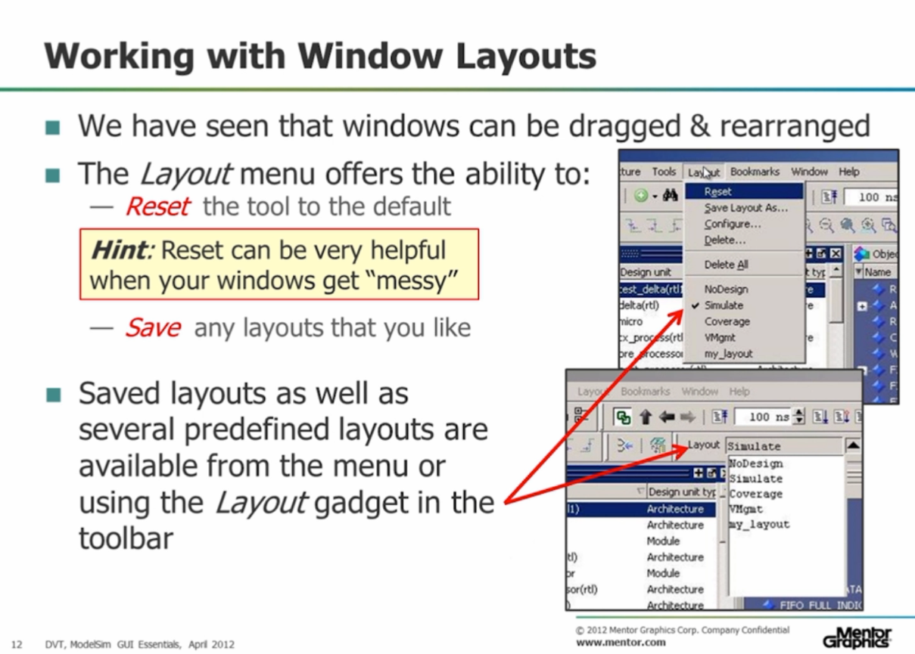

If we did something wrong with the layout, we can return to the default layout by selecting the “Layout” menu and clicking “Reset”.

If we liked the layout we created, we can save it and use it from the “Layout” menu or the layout gadget in the toolbar.

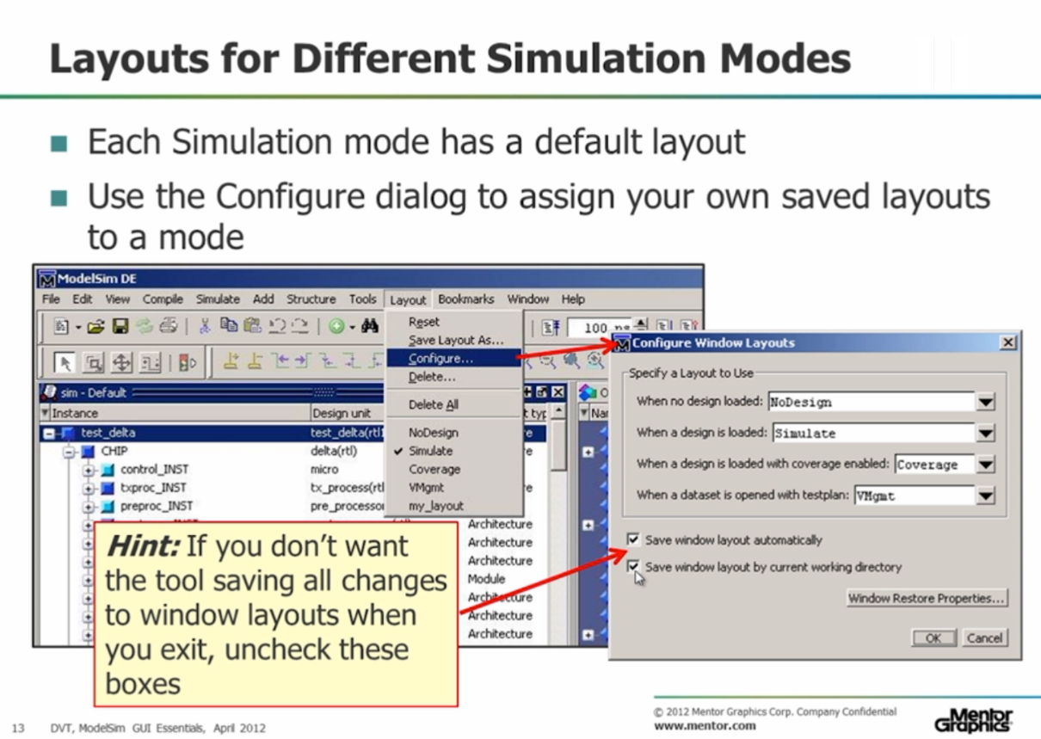

Each phase of the simulation has its own default layout. We can select these layouts in “Configure Window Layouts”.

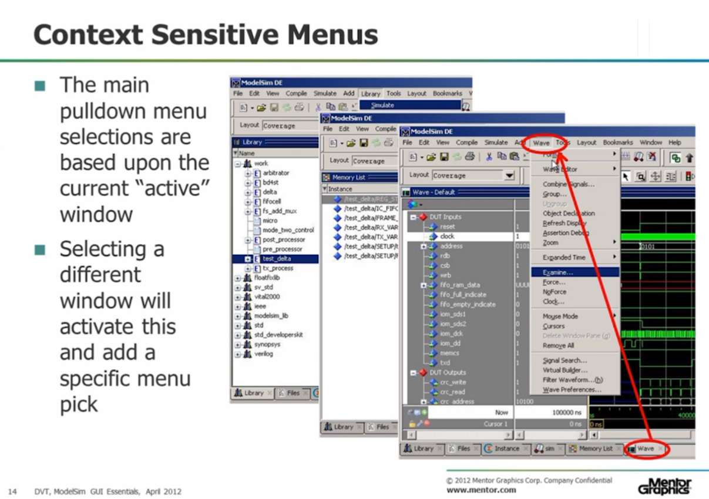

One of the main pulldown menus is based on the currently active window. It changes when we change the active window.

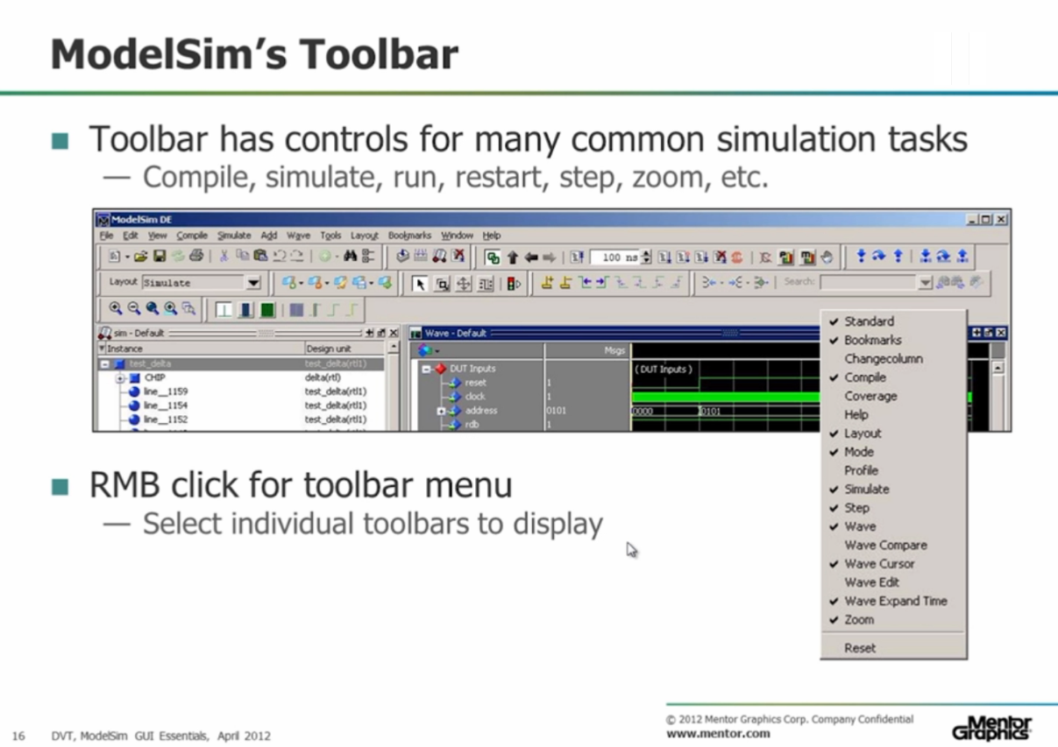

The toolbar has many common tools, and by right clicking on its unoccupied space, we can choose which tools we want to see.

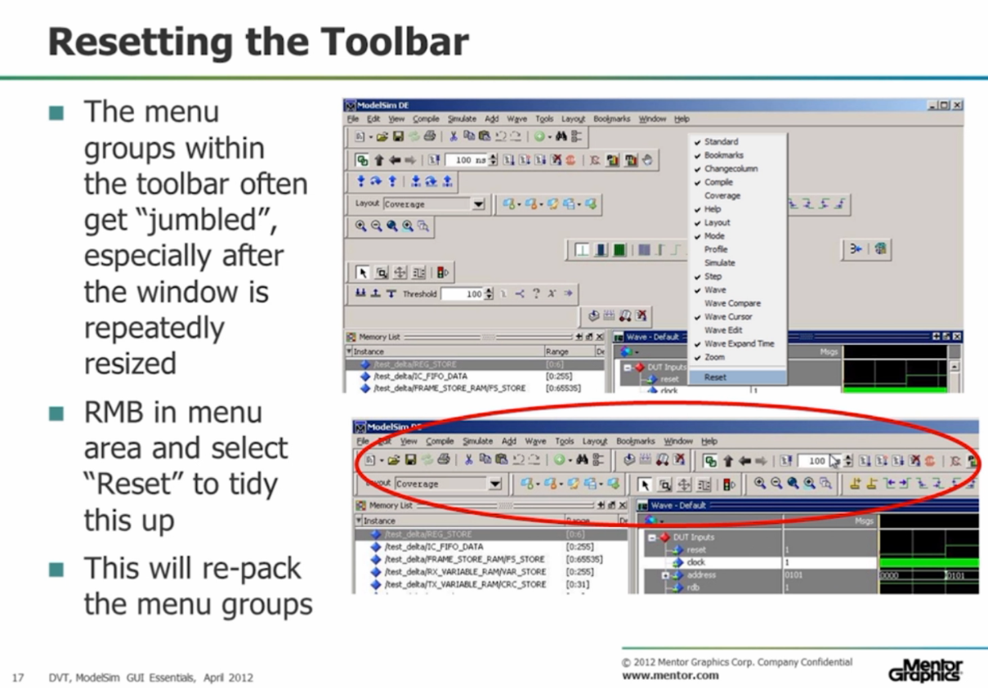

We can reset the toolbar by right clicking on unoccupied space and selecting “Reset”.

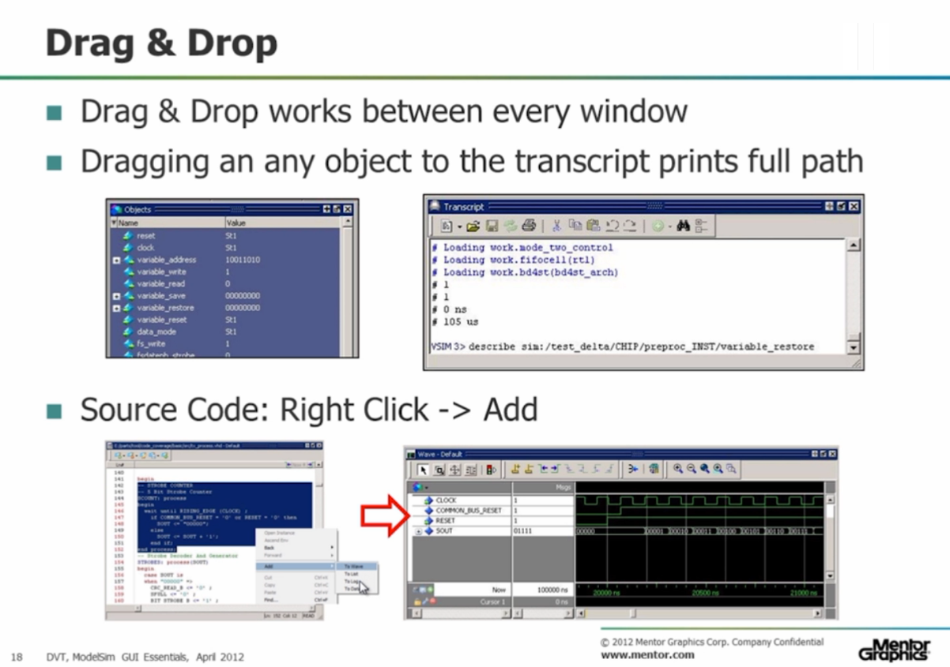  
We can drag and drop objects between most of the tools.

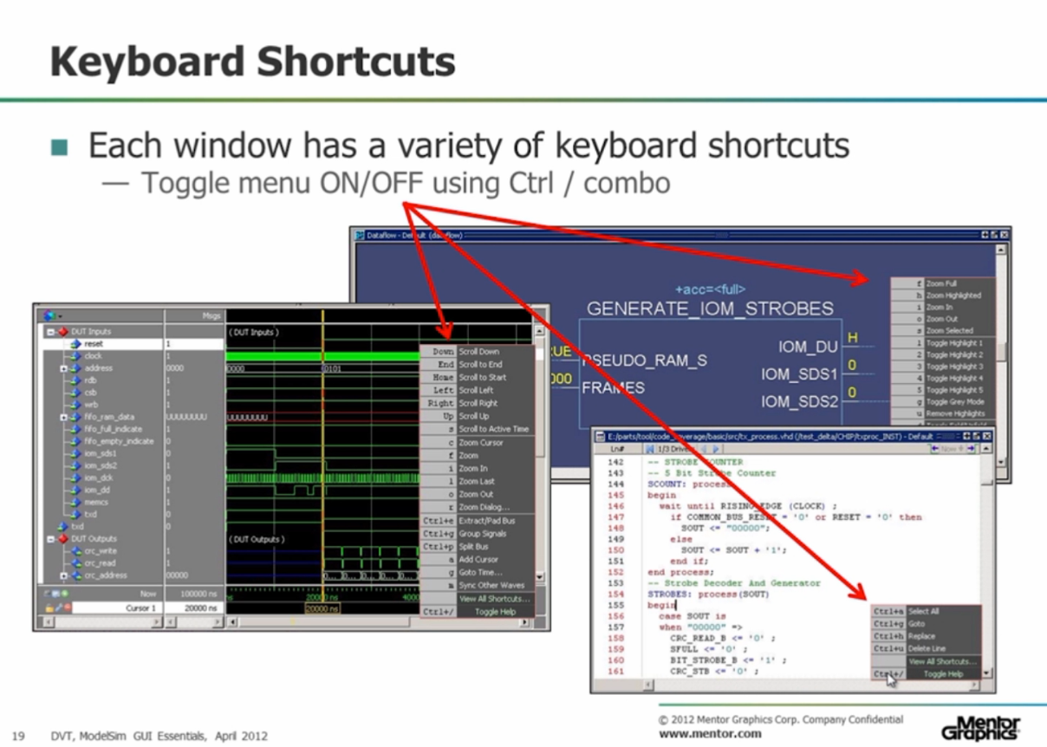

Each window has some keyboard shortcuts. To see them, we need to press “Ctrl+/”.

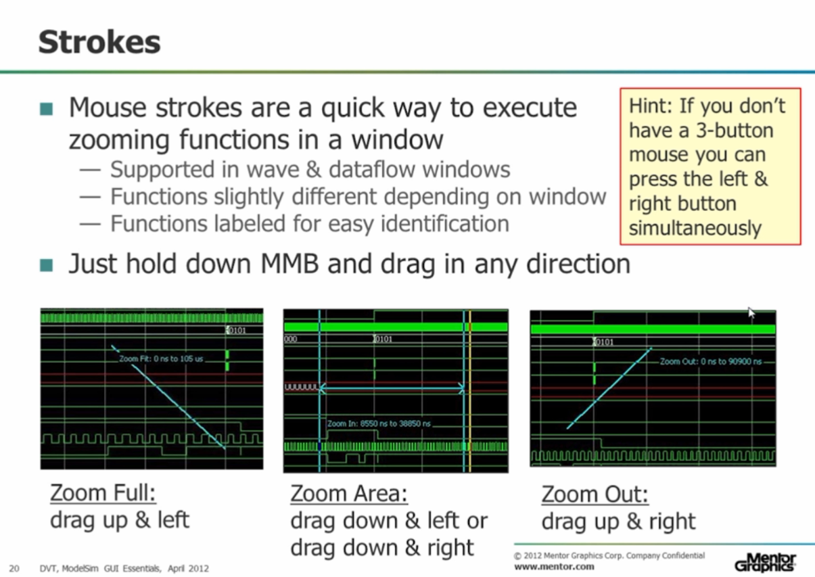

Strokes are very useful (especially in the wave window or in the data flow window). By pressing middle mouse button we can use Zoom Full, Zoom Area or Zoom out.

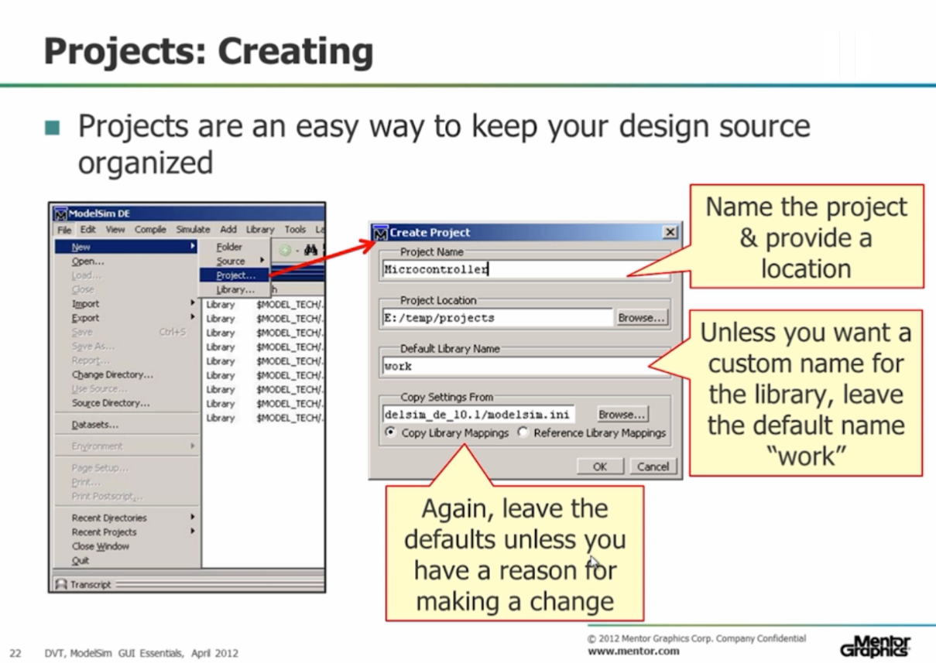

In ModelSim we can work in 2 modes: script mode and project mode. Project mode can help us in keeping all our data organized.

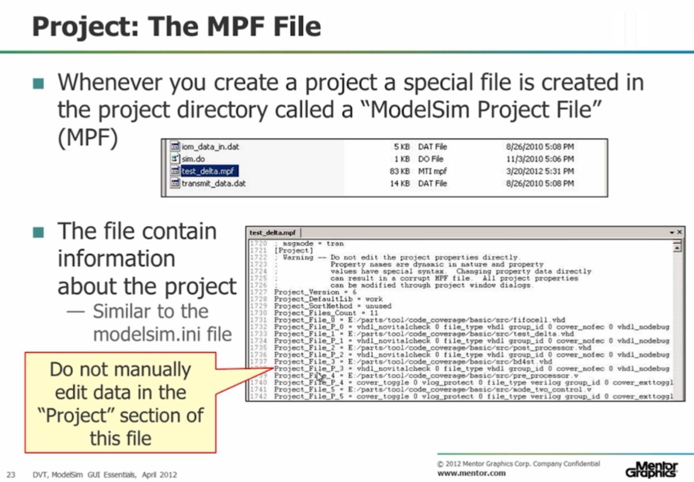

When we create a project, ModelSim creates a .mpf file that contains all the information about ModelSim configuration and project configuration.

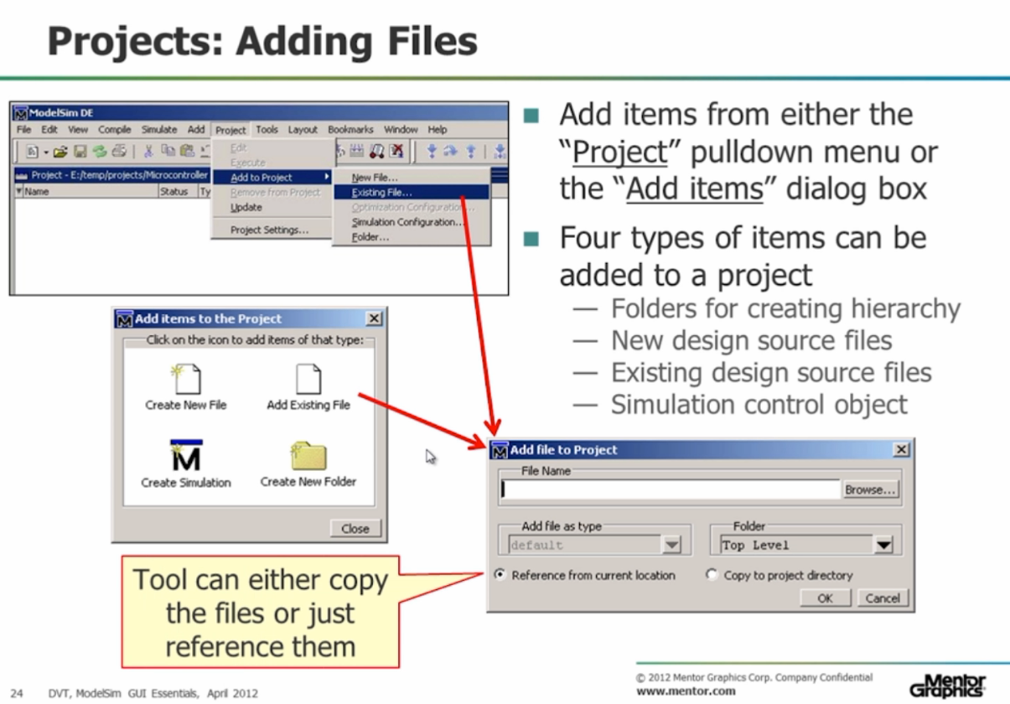

We could create new files in the project or add existing files.

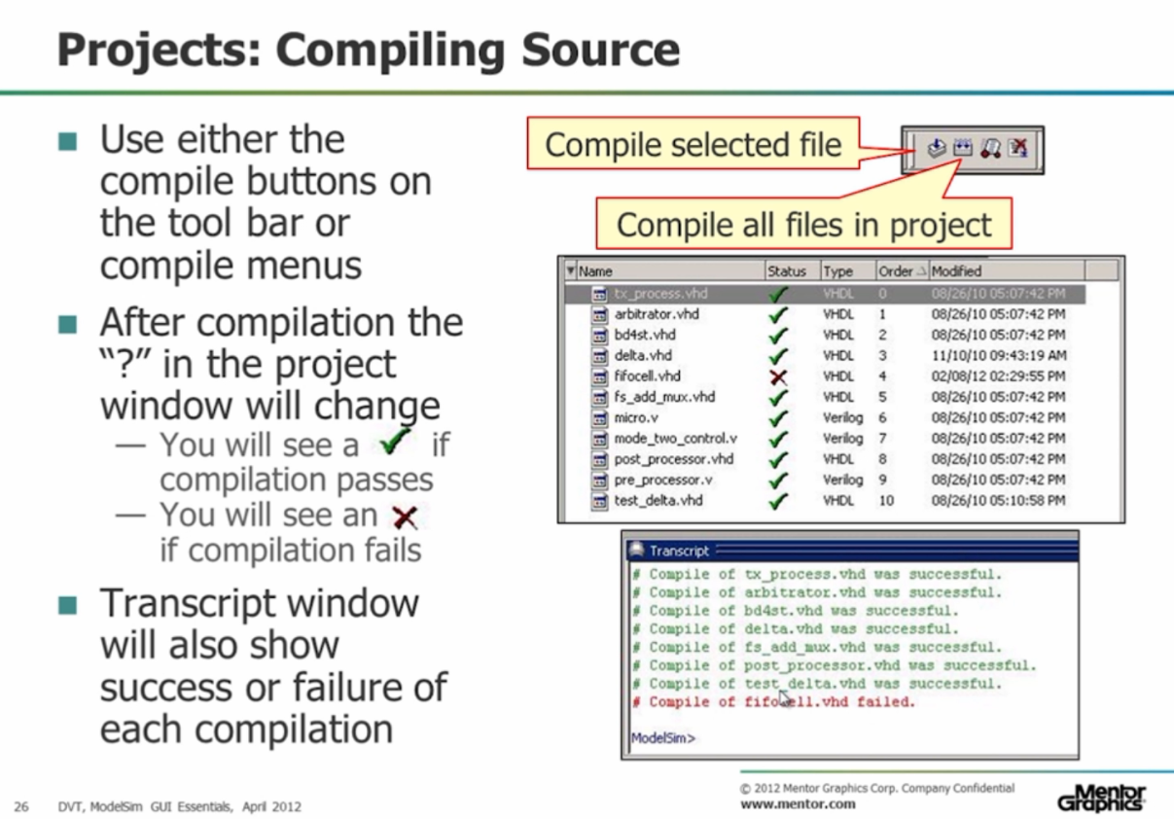

We could use compile tools to compile selected file or all files in project.

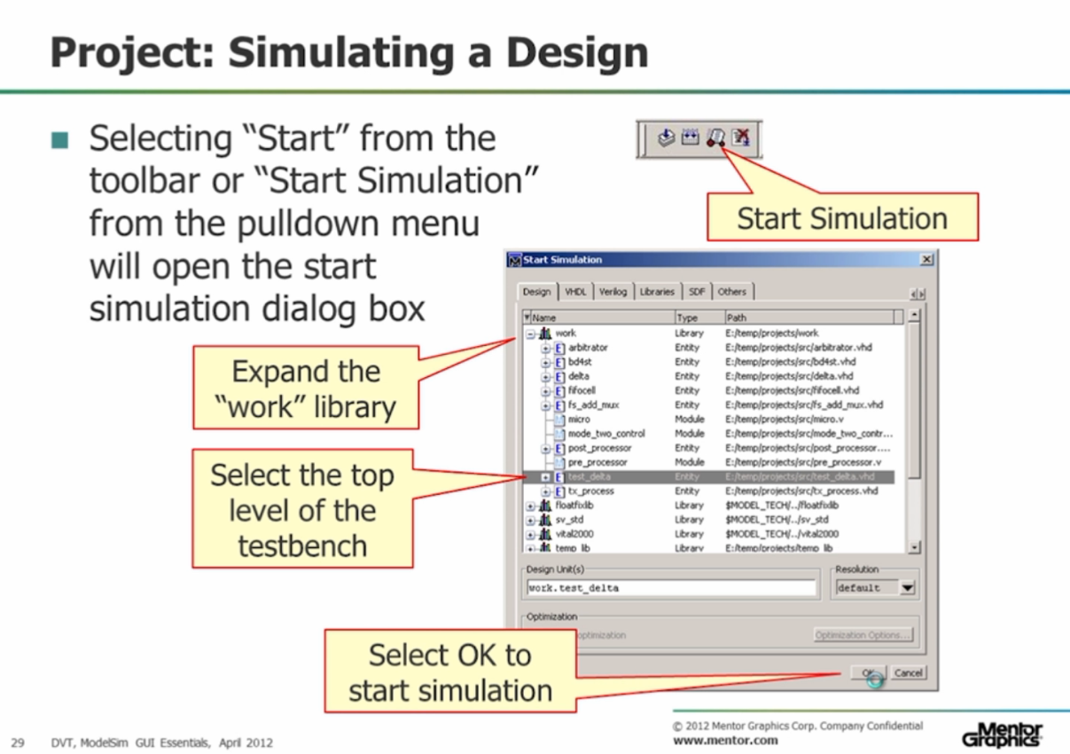

To start the simulation we need to select “Start” from the toolbar or “Start Simulation” from the pulldown menu and then select the top level of the testbench.

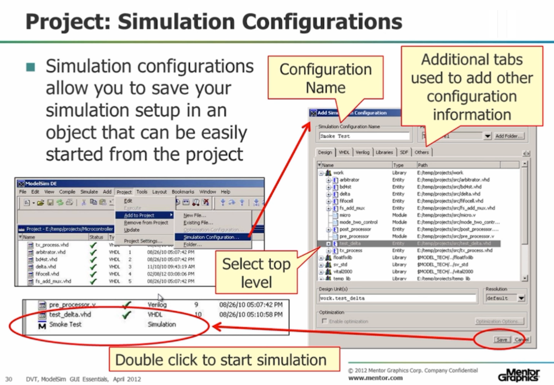

We can add special simulation configurations to our project by clicking “Project->Add to project-> Simulation configuration”.

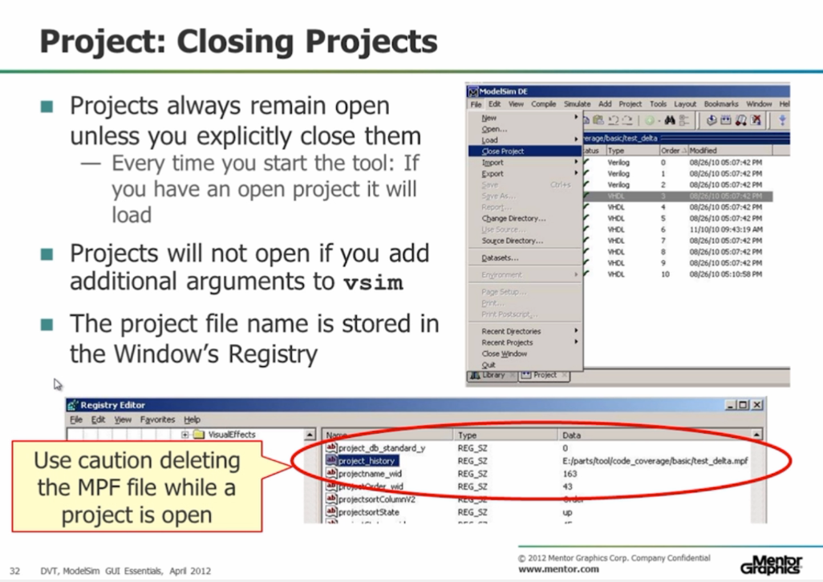

To close a project we need to click “File -> Close Project”.

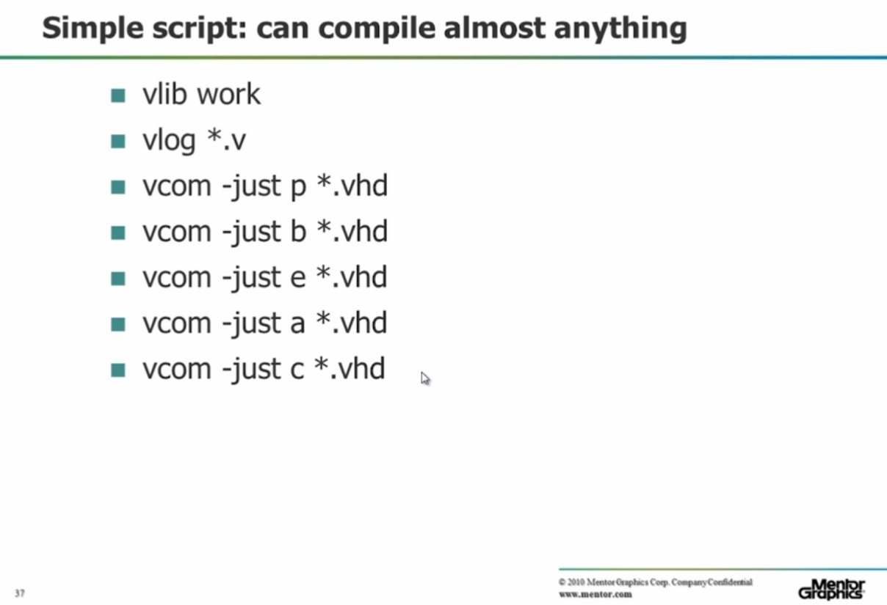

This script creates library called “Work” and compiles all Verilog code and other files from the project.

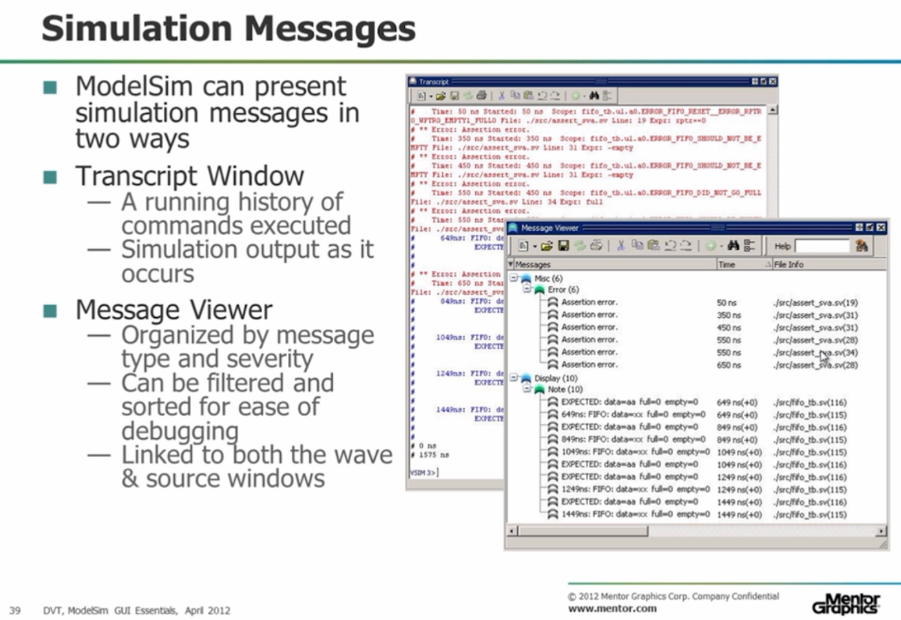

We can see simulation results in simulation messages.

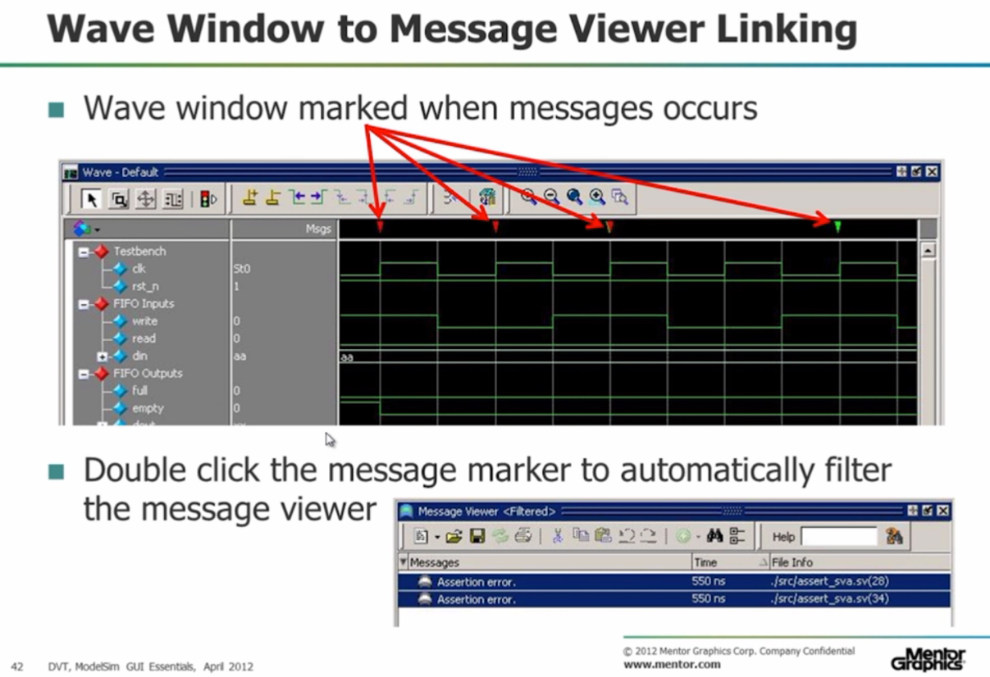

Cool way to bring a messages information into the Wave window. It helps us to filter and categorize messages.

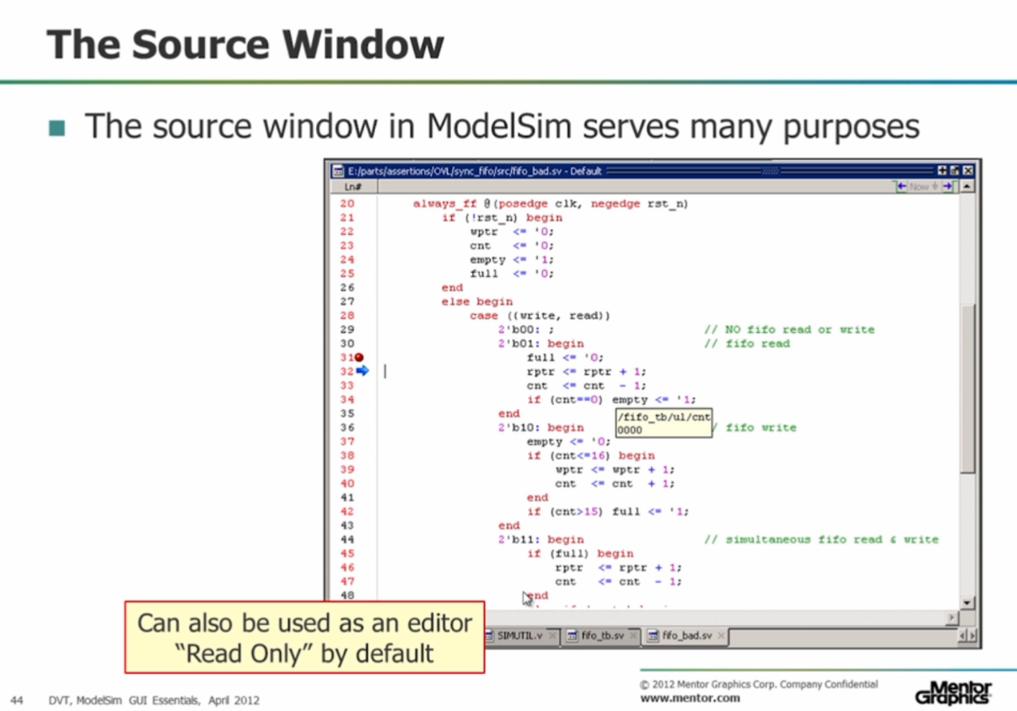

The source window in ModelSim has many purposes. Here we can see and write the source code or, for example, create the breakpoints and the special step arrows.

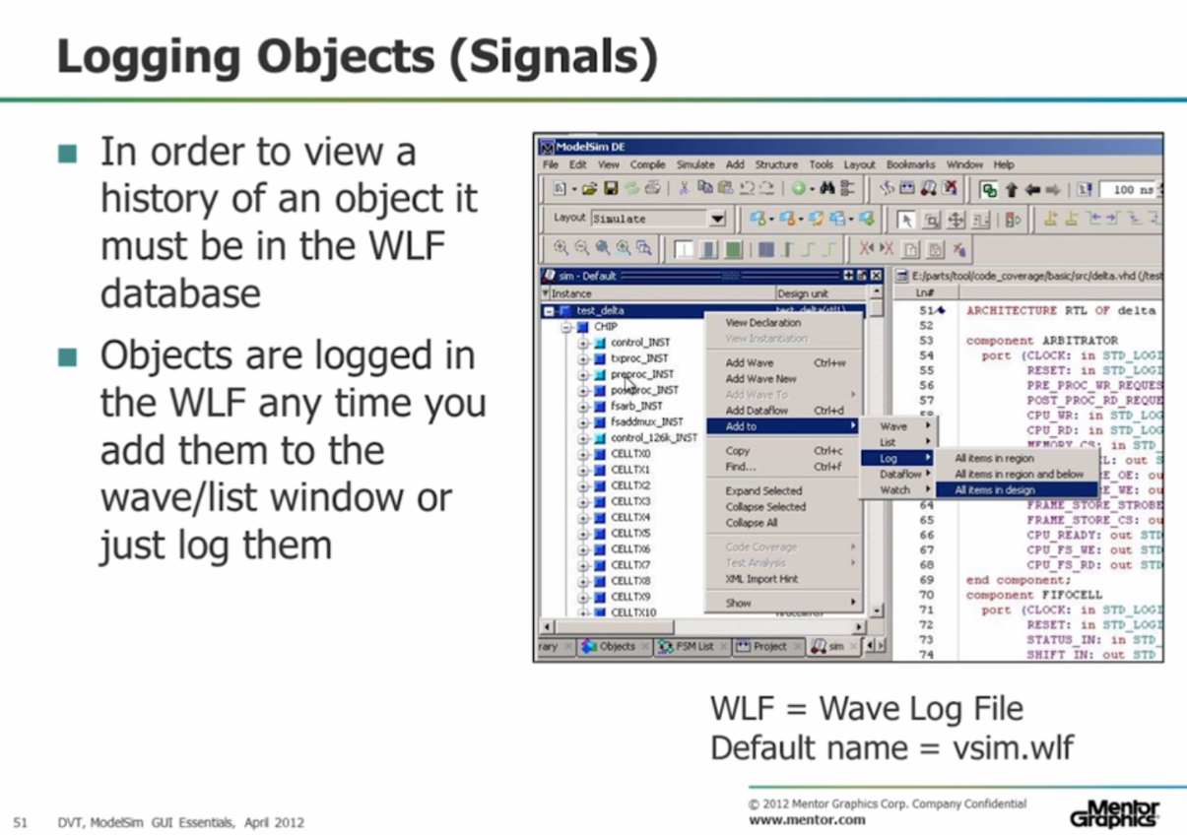

We can view a history of an object if it is in the WLF database.

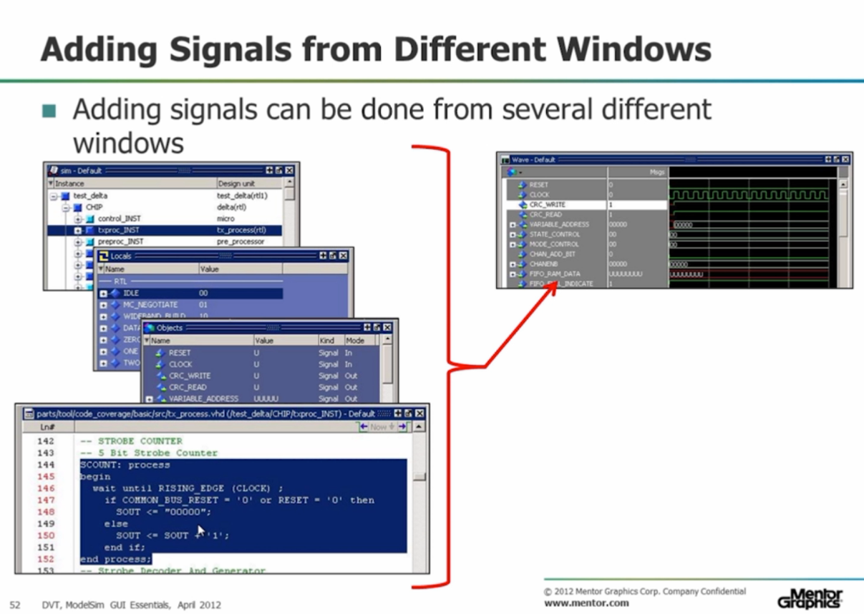

There are many ways to add signals to the wave window from different windows.

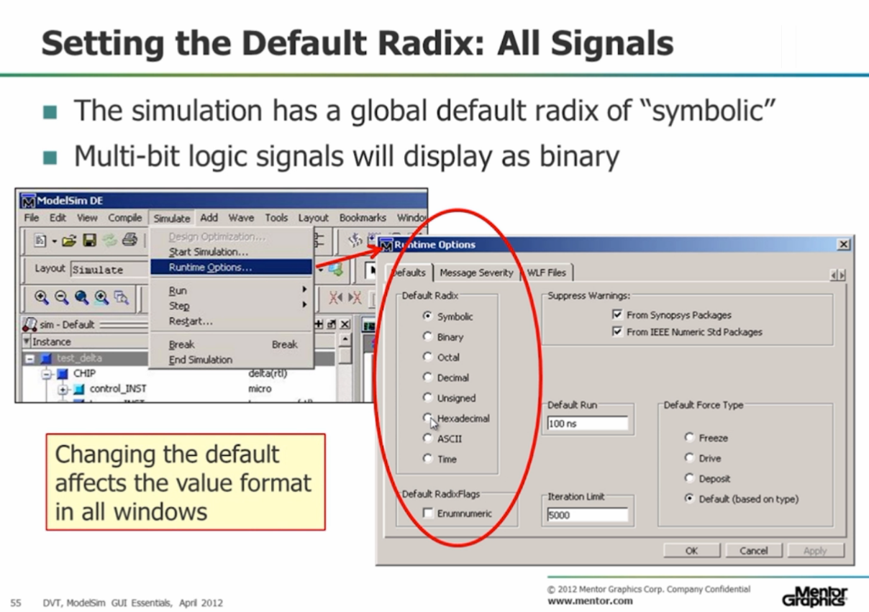

We can set the default radix by selecting “Simulate menu -> Runtime options”. There we can choose the default radix for signals.

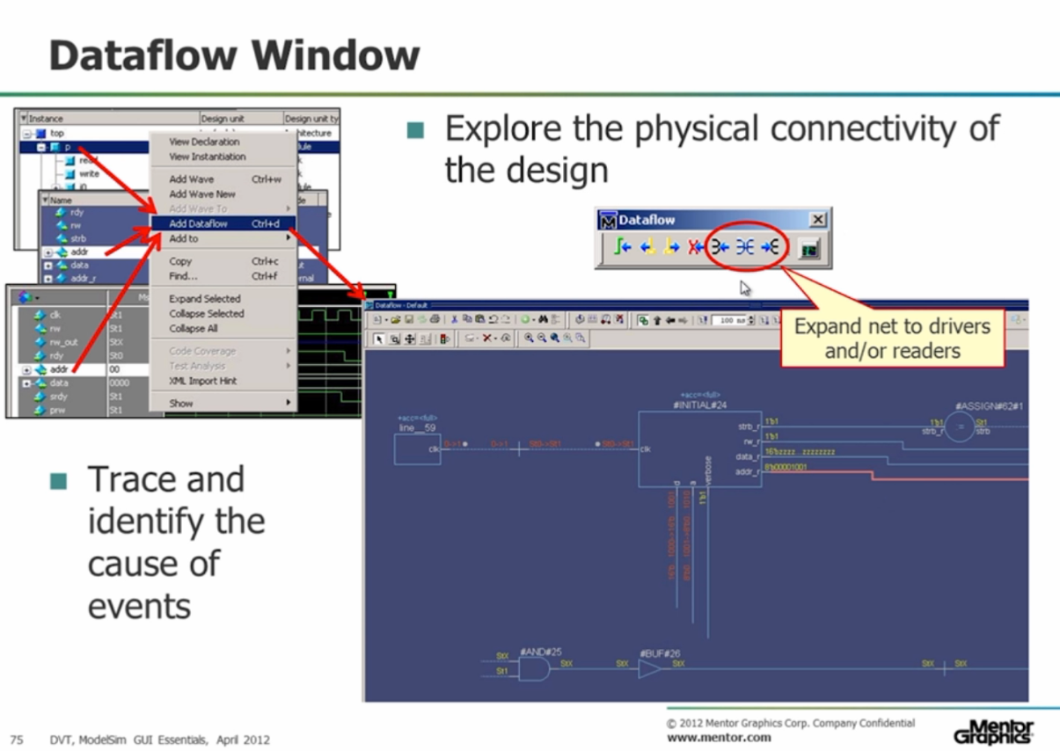

We can add signals from the Simulation view, Objects view or Wave window to the Dataflow window.

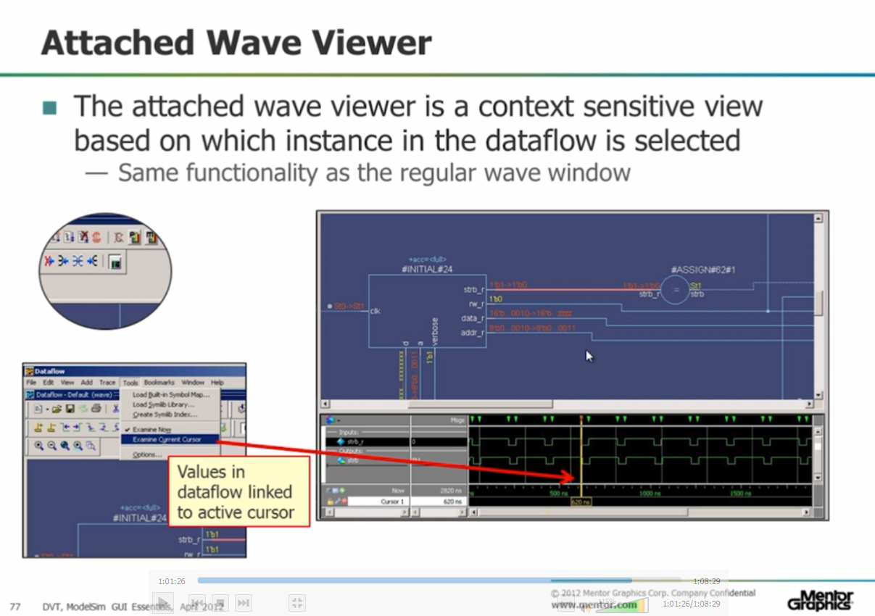

Using the attached wave viewer, we can get a context-sensitive view based on which instance in the data flow is selected.

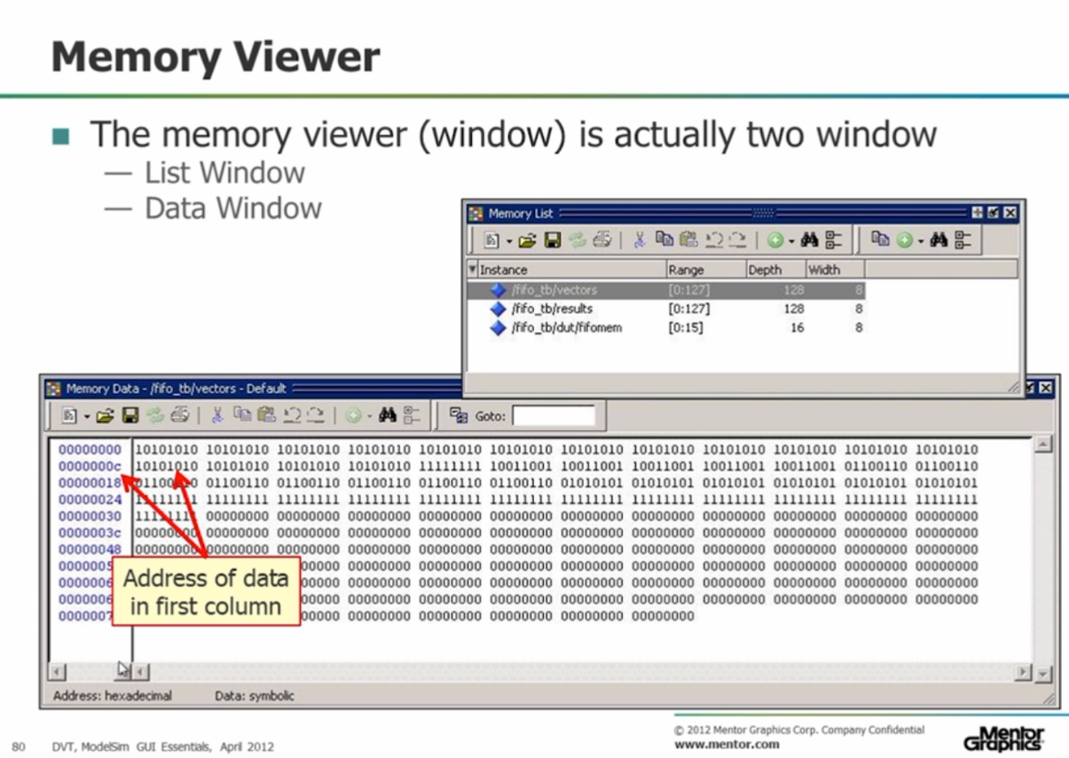

Memory list stores all memories with their dimensions.

Memory data shows actual data.

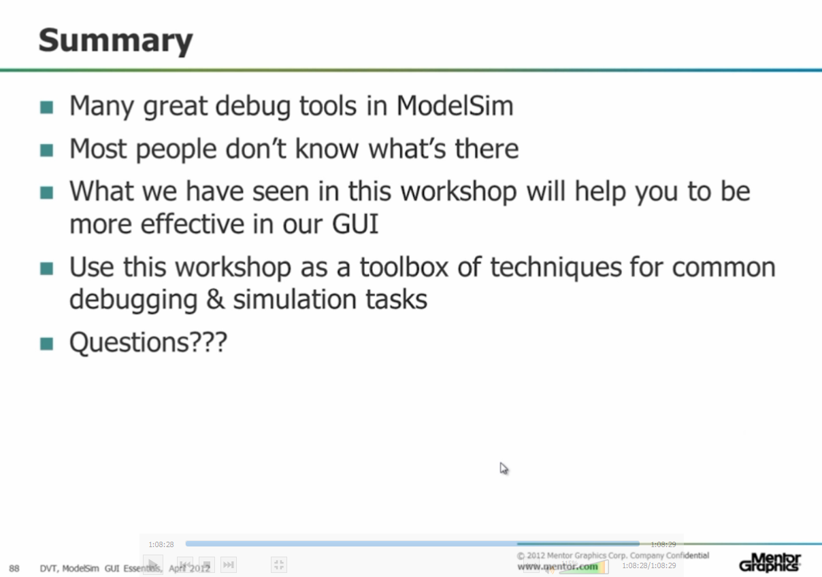

To sum up, ModelSim has many useful tools for debugging and it is important to know them, also, this lecture helped me become more effective in ModelSim GUI.